Dear colleagues,
I am grateful to Prof. Long Li, one of the authors of the article “Normal Anorectal Musculatures and Changes in Anorectal Malformation”, published in the journal “Pediatric Surgery International” in January 2020, for his willingness to discuss the pathological physiology of ARM and methods for their treatment.
The anatomy and physiology of anorectum are unique, i.e. there are no analogs in the human body. Only in the last 10-20 years, we began to come closer to understanding how long-term fecal retention and defecation are carried out. Numerous anatomical and functional studies, as well as long-term results of operations that preserve the anal canal or internal anal sphincter in patients with ARM, indicate that all patients with visible fistulas and most patients without a visible fistula have a functioning anal canal. It seems to me that the histological examination of Li et al brings us closer to understanding the pathological physiology of ARM.
Li et al describe the histological picture of anorectum in ARM when the ectopic anal canal, i.e., the internal anal sphincter, is in a closed state and is shifted anteriorly. In this situation, the IAS is not surrounded by longitudinal muscle fibers, as shown in the diagram from the article (Figure 1.A).

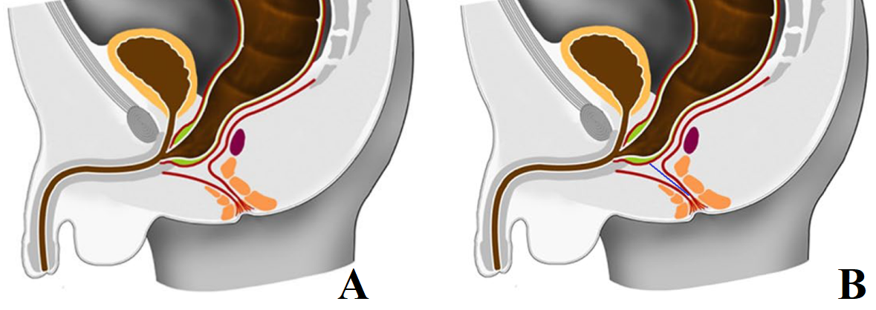

Figure 1. (A) Anorectum diagram of a male with a urethral fistula from the article of Li et al. The authors believe that "the perineal LMT (red lines from the fistula to the anal fossa) is fused to form a vertical column in both high and intermediate ARM". (B) I believe that the longitudinal muscle fibers at rest are in a closed state (blue line) and during the opening of the anal canal, they separate and an extended IAS approaches the anal dimple as shown in Figure 2. A.

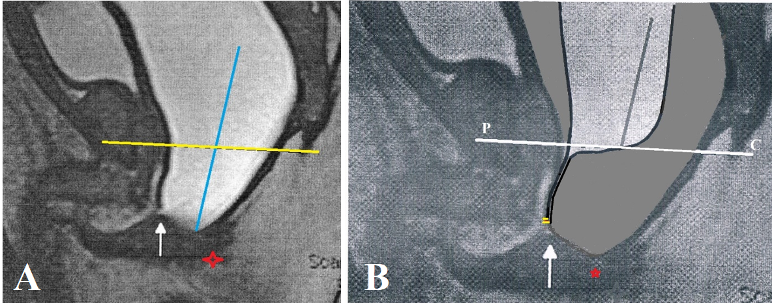
Figure 2. (A) MRI with augmented pressure distal colostogram in male with urethral fistula. The rectum is located above the pubococcygeal line (P-C line) (yellow line), sharply expanded. The gut located below the P-C line is an open anal canal. The arrow shows the connection of the anal canal with the urethra. A red asterisk is located in the alleged location of the anal dimple. (B) My reconstruction is the condition of the anal canal at rest, i.e. with low pressure in the rectum. The yellow lines represent the borders of the fistulous foramen. The white line is the P-C line.
I affirm that all children with an ARM with visible fistulas and most children without a visible fistula have a functioning anal canal. From the point of view of pathological physiology, this pathology should be called the ectopy of the anal canal. This is a low type of ARM. The ectopic opening is usually narrow and interferes with the normal emptying of the rectum, which is accompanied by chronic constipation and leads to the development of megarectum. Many authors find a pathological development of the longitudinal muscle layer of the anal canal in ARM, but it is worth noting that this muscle is very thin, not fixed and is not a sphincter. Although the anal canal in patients with ARM is clearly not normal, but since they do not have another, it is necessary to use all its elements to obtain the best parameters of fecal retention and defecation. Long-term results of operations preserving the anal canal prove the correctness of such tactics.
All links related to this problem are given in my previous posts, which can be read on my website: http://www.anorectalmalformations.com During the discussion, I am ready to answer any questions. In turn, I hope to get answers to the following questions.
1. Why split the center of the muscle complex and apply electrical stimulation if this center itself approaches the anal fossa during an increase in rectal pressure? In such cases, the distance from the gut to the skin in the anal dimple is 2 to 5 mm, depending on the age of the child.
2. If “in ARM, the IAST and the inner longitudinal muscular fibers of the rectum is absent”, then which sphincters cause a continuous contraction of the intestine located below the pubococcygeal line?
3. The authors state that "In ARM, the LMT is a closed muscular tube, which could be possibly dilated." How can on the basis of histological examination to differentiate whether the longitudinal muscle fibers are fused to a column or are they in a contracted state?
4. I believe that fibrotic changes and defects in the neuro-musculature appeared after birth due to chronic constipation, as is the case in patients with functional constipation. This is evidenced by the presence of a megarectum since it is written that “the distal dilated rectal pouch needs to be resected for better functional outcomes of the remaining gut”.
5. Normally, "The anal canal, defined from the upper rim of the puborectalis sling to the anal orifice, is the most important part for bowel control." In patients with ARM, the authors describe the presence of PRM in the following way: “It is found in this study that the puborectalis muscle sling in the high type ARM narrows and dislocates upward anteriorly; however, in the intermediate ARM, the sling is wider to fit the size rectal pouch and the rectobulbar fistula than in high ARM”. It is known that PRM occupies 40% of the anal keel in its upper part. Although the authors, following Peña, call this gut a rectal sac, it is obvious that we are talking about the anal canal.
6. The authors write that "While fecal retention, the internal anal sphincter contracts to maintain the resting pressure gradient in the anal canal and the rectum relaxes and performs a cumulative role." So why do they pull-through the rectum instead of the anal canal? The rectum cannot function as an IAS.
7. Authors' claim that in patients with ARM the sensitivity of the rectum is impaired and that “the muscles in the TMT in ARM are maldeveloped and the number of the muscle spindle in ARMs is significantly fewer than in normal, which are responsible for poor anal sensation", not corresponds to reality, since the rectoanal inhibitory reflex and defecation reflex in them are not disturbed.
The authors of the article set their goal to justify the pull-through operation and in their work refer only to works confirming the correctness of their opinion. I appeal to the authors to cite only scientific facts. Assumptions and hypotheses are not scientific facts and cannot be accepted as evidence.
I hope that other children's surgeons, anatomists, and physiologists will join our discussion.
Respectfully
Michael Levin

