Dear Colleagues,
I return to the problem of ARM without a fistula with new arguments. The basis of the work is a discussion between two positions. In the first part, the arguments of pediatric surgeons who deny the presence of the anal canal and the importance preserving of the puborectalis muscle and internal anal sphincter during the correction of the defect are analyzed. Another group of scientists from Finland (Part 2) recognizes the importance of the puborectalis muscle and internal anal sphincter для удержания кала. At the end of the 2nd century, Dr. Rintala was the only scientist who continued to argue for the presence of the anal canal at low ARM, and this inspired hope. Good treatment results in patients with low abnormalities in this group of surgeons are undeservedly ignored. It only surprises me that in their articles, in fact recognizing the presence of the anal canal, they call the internal anal sphincter a rectal pouch. I hope they clarify their position on this issue.
respectfully
Michael Levin
nivel70@hotmail.com
https://www.anorectalmalformations.com

Amicus Plato, sed magis amica veritas

Anorectal malformations without fistula: Theory, practice, and dogmas
Part I.
The absence of the anus in the anal dimple necessitates a study of the perineum to detect fistula. If within 30 hours of the newborn’s life no signs of a fistulous opening and meconium in the urine were detected, we are talking about ARM without a visible fistula. All classifications evaluate the ARM without a visible fistula as a high type of abnormality. A common tactic is the creation of a colostomy in the first days after birth. The final diagnosis is established a few months later on the basis of a distal colostogram after the exclusion of the urethral fistula and rectobladder neck fistula [1,2].
- First dogma. The statement: “the presence of an extensive common wall between the rectum and urethra in males or vagina in females” [1], has no evidence.
Firstly, in 90% of boys, the urethral fistula is located below the pubococcygeal line [2], so the wall of the anal canal, and not the rectum, is tightly adjoined to the urethra. Secondly, there are no histological and embryonic studies confirming the presence of a common wall. Third, a study by Pakarinen et al proved that "the distal termination of the rectum, we did not find either intimate contact between the urethra and the distal termination of the rectum in low forms or a common wall between the 2 structures in high forms of imperforate anus without fistula" [3].
- Second dogma. "The location of blind rectum was at the level of the bulbar urethra in males or 1-2 cm from perineal skin in females in 80 patients (90%)" [1].
These figures are not tied to age or weight, therefore do not correspond to reality. In addition, the rectum, as in healthy located above the pubococcygeal line, 1.5 cm from the anal fossa in premature newborns and 1.7 cm at full-term [4]. As shown in the article by Kraus et al, the intestine located caudal to the distal coccygeal vertebra, that is, below the pubococcygeal line, is in the center of the muscular complex. At rest, it is in a closed state and opens wide under high pressure in the rectum [2]. The description leaves no doubt that at least 90% of patients with urethral fistulas, without fistulas and with vestibular fistulas have a functioning anal canal [5]. At high pressure in the rectum, the reflex opening of the anal canal occurs. Then the distance from the blind end of the intestine to the skin in the anal fossa is ≈2-3 mm, depending on the thickness of the subcutaneous tissue, that is, the weight of the child [4] (Figure 1).

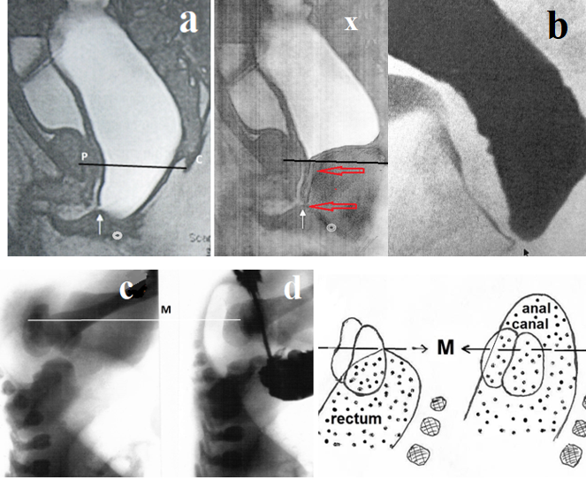
Figure 1. (a) MRI augmented-pressure distal colostogram. High hydrodynamic pressure caused a constant opening of the anal canal and the short fistula near the bulbar urethra (white arrow). Contrast in the urethra is visible during urography. The anal dimple (white circle) is located ≈ 2-3 mm from the distal wall of the open anal canal. (x) When the pressure in the rectum decreases, the anal canal contracts (red arrows). It is fixed by the tissues of the fistula to the bulbar urethra (reconstruction of figure “a”). (b) Augmented-pressure distal colostogram of the same patient. There is no evidence that the fistula is functioning since the contrast medium does not penetrate from the rectum into the urethra. (c) Invertogram of a newborn with ARM without a visible fistula, performed at rest. The distal contour of the rectum is located on the "M» line (see scheme). (d) After the erroneous introduction of contrast medium into the perineal tissue (instead of the rectum), the anal canal opened, and gas is visible close to the perineal skin. Line "M" is drawn through the border of the middle and distal third of the shadow of the sciatic bone, corresponding to the pubococcygeal line.
- Third dogma. “Anorectal malformations without fistula: a defect with unique characteristics” [1].
Normally, in the post-cloacal period, the endodermal internal anal sphincter migrates in the craniocaudal direction to meet with the ectodermal portion. The junction of the cloister (endoderm) and the anal pit (ectoderm) is the final stage of the creation of the anal canal. With ARM, there is no hole in the anal fossa, which is convincing evidence that the ectodermal element of the anal canal has not been activated in the embryonic period. Not having met in its path ectodermal part of the IAS, the proximal part of the IAS continues to migrate with the deviation forward. It has a high proteolytic and creative activity. Penetrating through the subcutaneous tissue and skin, it creates a perineal fistula. Penetrating through the wall of the vestibule, it forms a vestibular fistula in females or urethral fistula in males. The fistula fixes the last point of IAS to the place of penetration. However, the most caudal place that the fistula passed at an earlier stage of its development is always 2-3 mm from the anal fossa, regardless of the site of penetration [5].
In terms of pathological physiology and treatment, there is no difference between an ARM without a fistula and an ARM with a non-functioning fistula. Some authors believed that in almost all cases, IAS penetrates somewhere, but does not always function [6]. It cannot be ruled out that in some cases, the migration of the anal canal ends before reaching any cavity due to the genetic weakness of the proteolytic or creative function of the endodermal part of the IAS. This may affect the timing of removal of the tracheostomy tube from the anal canal after PPP [5].
- Fourth dogma. The “finding confirm our impression that we were dealing with malformation with reasonably good function prognosis” [1].
The goal of pediatric surgeons is to study the pathological physiology of ARM and long-term results after different treatment methods, in order to choose a more successful method than would maximally retain all the functions of the pelvic floor organs. "The outcome of low anomalies (with good function prognosis) has traditionally been considered good. However, recent more critical long-term follow-up reports show a different picture. Many patients with low anomalies suffer from long-term anorectal functional problems, especially constipation but also soiling that occurs in a significant percentage of patients" [8].

Part II.
Imagine the situation. An explosion occurred during a test of a space rocket. You have no doubt that scientists, engineers, builders have discussed all the options to establish the cause and eliminate it in the next launches. Why was in pediatric colorectal surgery the last open discussion in 1982 when analyzing Peña’s article? [8]. I suggest you analyze 2 interesting ideas that were forgotten and not developed due to the lack of a culture of scientific discussion.
In 1990, Stevenson et al described perineal anoplasty in patients with a low imperforate anus without visible fistula. Pouch localization was carried out preoperatively by fluoroscopic percutaneous transperineal placement of a Fogarty embolectomy catheter through the center of the anal wink. They have used this technique in four consecutive patients where the rectal pouches were 1.0 to 1.5 cm from the perineum. Although "results have been excellent" [9], additional observations and long-term results were no longer published.
In 2005, Pakarinen et al published transanal endoscopic-assisted proctoplasty [3]. The upper pouch was intraluminally visualized using retrograde endoscopy through the sigmoid mucous fistula. The distal termination of the rectum was clearly identified as by convergence of the anal columns. Bright translumination of the endoscope light from the rectum to the anal dimple within the external sphincter indicated a low malformation amenable to transanal proctoplasty. In these cases, an endoscope needle (7 mm) was advanced through the midpoint of the anal column convergence to the anal dimple, and its location within the sphincter muscles was confirmed. An incision with the exit site of the needle in the midpoint was made to open the air-filled rectum from below under endoscopic visual control. After gentle dilatation of the anus to the appropriate size, the full thickness of the rectum was transanally stitched to the perianal skin. Poor translumination indicated a higher defect, in which case, the operation was converted to standard posterior sagittal anorectoplasty.
Authors found that in low forms of imperforate anus without fistula, the midpoint of the distal rectal termination is right above the anal site within the sphincter muscle complex and not intimately related to the urethra. They believed that transanal endoscopic-assisted proctoplasty enables anatomical anorectal reconstruction under direct visual control without either extensive anorectal dissection or any division of the sphincter musculature avoiding the potential complications associated with the open posterior sagittal approach. Since the authors have never reported the use of this approach since then, it is highly likely that their hope of a good functional result did not materialize.
Thus, two new treatments for ARM without fistula [9.3], which theoretically gave hope for a breakthrough in the treatment of patients with ARM, did not live up to the expectations of researchers. I believe that these researchers violated the ethical standards of scientists. Instead of publishing negative results of the study, and open a discussion to finding out their cause, they tried to forget about the failure.
Stevenson et al. introduced a Fogarty catheter in "the pouches 1.0 to 1.5 cm from the perineum" [9]. This means that in the case with a distance 1.5 cm the catheter was inserted into the rectum. In cases where distance was 1 cm, the catheter was inserted into the incompletely opened anal canal, i.e., into the sidewall of the internal anal sphincter. Probably, the results would be different if the catheter was inserted during the abdominal compression, which would lead to the full opening of the anal canal when the distance between the blind sac and the anal canal is 2 mm.
The method proposed by Pakarinen et al. eliminates the drawback described above, but in 4 patients with low defect, the results probably were not better than after PSARP.
Let's compare the two methods of operation.
From the point of view of pathological physiology, ARM without fistula have an advantage over ARM with fistula in the perineum. In both cases, the distance from the distal contour of the opened anal canal to the anal dimple in newborns is 2 mm (Figure 2).
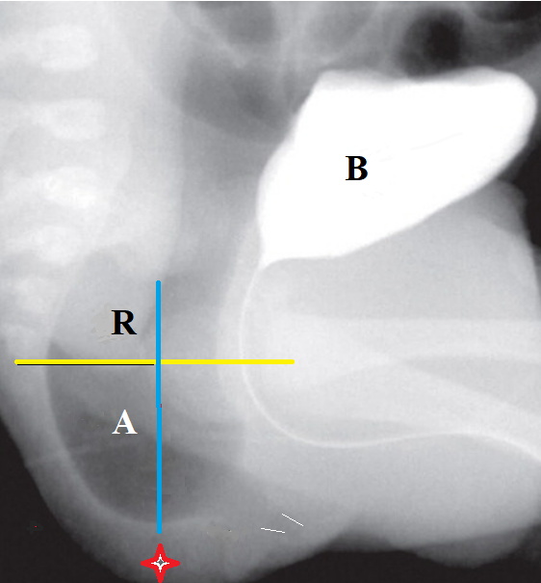
Figure 2. X-ray of a newborn with an ARM with a perineal fistula, performed during the anal canal opening. The pubococcygeal line (yellow) separates the rectum (R) from the anal canal (A). The distance between the distal contour of the anal canal and the anal fossa (red asterisk) is ≈2 mm. The perineal fistula is displaced forward (white lines) unusually far from the anal fossa. Gas from the anal canal does not disappear, which indicates that the fistula is not functioning.

However, with a perineal fistula, there is a narrow fistulous opening. Due to the presence of fistula and stool, the diagnosis is usually made late. In some cases, a megarectum develops by this time, which can be the cause of constipation after surgery. In newborns without fistula, the width of the rectum has not yet expanded.
Meanwhile, the results of the treatment of patients with perineal fistula are not much different from the control. "All males treated for low ARMs with cutback anoplasty, incision of anocutaneous membrane or dilatations based on the exact type of each malformation between 1983 and 2006. Amongst 46 respondents (67%; median age 12.3 (5-29) years), overall fecal control was comparable to controls (p = NS). All patients had voluntary bowel movements; 98% of patients and 97% of controls were socially continent (p = NS); 67% of patients and 64% of controls were totally continent (p = NS). Constipation amongst patients (33 vs 3% in controls; p < 0.0001) declined significantly with age. Outcomes by bowel function score were good in 85%, satisfactory in 15% and poor in 0%. Prevalence of LUTS and age at completion of toilet training were comparable to controls (p = NS)" [10].
- Fifth dogma. All surgeons who preserve the internal anal sphincter separate it from the surrounding tissue.
The difference that dramatically worsens the results of treatment with transanal endoscopic-assisted proctoplasty compared to cutback anoplasty is that in order to sew the wall of the internal anal sphincter to the skin of the perineum without tension, it was necessary to separate it from the surrounding tissues. After transanal endoscopic-assisted proctoplasty, the devascularized and denervated IAS is in the wound tunnel. Healing occurs because of an inflammatory reaction with the formation of fibrous tissue. The addition of microbial inflammation enhances the formation of fibrous tissue.
The internal anal sphincter has such a thin wall that during dissection of the perineum, when the anal canal is in a closed state, it is impossible to distinguish it. Therefore, during PSARP, this sphincter is invisibly destroyed. Its role as an independent sphincter is greatly exaggerated. It plays an important role in stool retention only in cooperation with the external anal sphincter (EAS) and puborectalis muscle (PRM). The intersection of nerve fibers that connect IAS with other participants in the rectoanal inhibitory reflex leads to the destruction of the reflex arc.
Kirkland et al found that patients with mild ARMs displayed good anorectal function after minimally invasive treatments. The median anal resting and squeeze pressures among patients with mild ARMs (60 cm H2O and 116 cm H2O respectively) were significantly higher than among patients with more severe ARMs (50 cm H2O, and 80cm H2O respectively; p≤0.002). The rectoanal inhibitory reflex (RAIR) was preserved in 100% of mild ARMs and 83% of patients with more severe malformations after IAS-saving sagittal repair. The functional outcome was poor in 4/5 patients with an absent RAIR (bowel function score ≤11 or antegrade continence enema-dependence). Rectal sensation correlated significantly with the bowel function score [11].
The RAIR is excited with increasing pressure in the rectum and is manifested by the relaxation of IAS with a simultaneous contraction of the EAS and PRM, which inhibit (prevent) involuntary defecation (Figure 3). The work of Kirkland et al duplicates the misconception common among pediatric surgeons. They considered a decrease in pressure in the anal canal as a manifestation of a rectoanal inhibitory reflex.
However, a decrease in pressure in the distal part of the intestine in response to stretching of the proximal segment corresponds to Bayleys and Starling's gut law of the intestine. "This law is as follows: - Local stimulation of the gut produces excitation above and inhibition below the excited spot. These effects are depended on activity of the local nervous mechanism" [12].
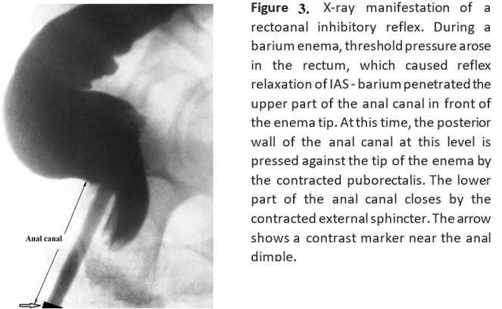
The authors emphasize that "the motor mechanism of the intestinal wall is moreover extremely sensitive to changes in the blood flow through the vessels of the gut" [12]. It follows that a decrease in pressure at the level of the neoanus can also be caused in the rectum. This is confirmed by Lin and Chen. They discovered rectoanal relaxation reflex in ARM patients after Rehbein's mucosa-stripping endorectal pull-through combined with anterior sagittal anorectoplasty (none internal sphincter-saving) and concluded that the internal sphincter-saving procedure is not essential for the development of the rectoanal relaxation reflex [13]. Bayleys and Starling studies indicate that relaxation of the neoanus testifies only normal blood supply to the intestine: the rectum or IAS.
Analysis of the literature allows us to understand why the preservation of IAS after isolation from surrounding tissues does not justify the hope of a favorable result. Thin-walled denervated IAS at best relaxes in response to the expansion of the rectum. A fibrous tissue forms around it, which limits the possibility of the anal canal opening compared to the norm during defecation. This causes constipation, megarectum, and fecal incontinence because of secondary damage to the puborectalis muscle and elevator plates.
- Sixth dogma. All surgeons consider it necessary to sew the rectum or anal canal to the skin of the perineum.
Firstly, the sutures that connect the anal canal to the skin disrupt the vascularization of both tissues and cause an inflammatory reaction leading to scarring. Secondly, IAS and after birth retains the ability to regenerate. For example, in the Belarusian Center for Pediatric Surgery in patients with visible fistulas, an operation was performed to create the anus inside the subcutaneous portion of the external sphincter, followed by closing the fistula. In some cases, the closure of the fistulous opening was performed repeatedly. The analysis showed that the fistula reopens if the closure of the fistula is not hermetic, or the wall of the anal canal enters the wound.
When I worked at the children's surgical center in Minsk and diagnosed a low type of ARM without fistula, surgeons were founding the rectum at 2 cm from the anal fossa. During anesthesia, the pressure in the rectum decreases, and the anal canal closes. During tissue dissection, surgeons walked past a closed IAS and destroyed it. I managed to do 4 perineal perforation procedure (PPP) during the anal canal opening [4]. The wall of the IAS did not stand out and was not attached to the skin. One child died after the correction of esophageal atresia. In three cases, the function of the anal canal did not differ from the norm. A detailed description of one of the 3 cases you can see here [14].

The perineal perforation procedure (PPP) (Figure 4).

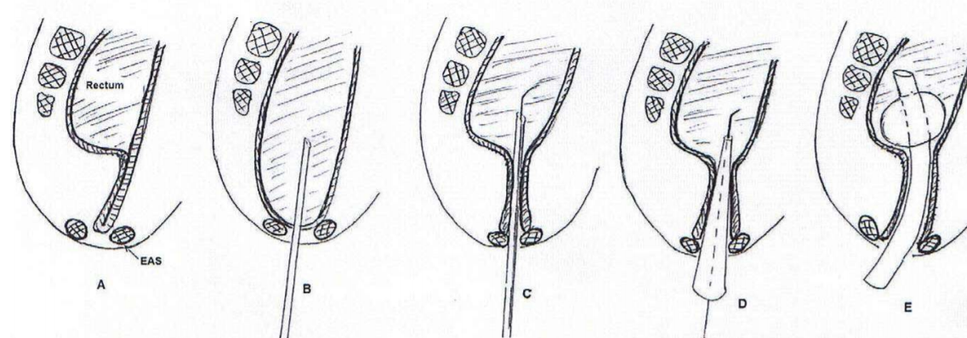
Figure 4. Scheme of the "perforation perineum procedure" (PPP) to treat low imperforate anus without visible fistula. Lateral view.
A. The anal canal is closed. B. The anal canal is opened due to abdominal compression. Under X-ray control, a needle is introduced into the anal canal. C. Conductor for vascular catheterization is introduced into the rectum through the needle. D. The tapered dilator introduces on a conductor for the expansion of the newly created channel.
E. After removal of the dilator, the tracheostomy tube introduced along the conductor. Its balloon is inflated in the rectum.
Operation. On the X-Ray table under general anesthesia, the cross-section of skin produced above the contraction of the subcutaneous portion of EAS. After stretching of its fibers, the child transferred to a lateral position. During abdominal compression, when the anal canal opened, the needle inserted from an incision in the skin into the rectum through the open anal canal (Figure 4. A-B). Only that step performed under fluoroscopic control. The sound of gas escaping indicate that the needle is in the rectum. Then, a conductor with a soft floating end inserted through the needle into the rectum (Figure 4. C). The needle is removed and the tight conical bougie with a maximum diameter of 0.8 cm is introduced into the gut along the conductor (Figure 4. D). After that, the tracheostomy tube with a diameter of 0.8 cm introduced into the rectum, and the conductor was removed (Figure 4. E). Five cm³ of air is introduced into the balloon of this tube that allows us to fix the tube for 7 days. The IAS does not mobilize and not sewn to the skin. After 7 days, the tube is removed. After 2 weeks after surgery, daily dilation of the anal canal begins until it reaches the normal diameter.
Conclusion If a newborn with an imperforated anus within 30 hours after birth no fistula was found and no meconium in the urine, fluoroscopy should be performed in a horizontal position on the side with compression of the abdomen. If there is no gas in the rectum, then need to find a fistula through which the gas is vented. If during compression of the abdomen the gas approaches the skin of the perineum and does not disappear from the anal canal, ARM without fistula should be diagnosed. The presence of a tracheostomy tube with a diameter of 8 mm allows you to press IAS to the tissues of the perineum without damaging them. IAS regeneration occurs around the perimeter of the anus around the tube for a week without scarring with an initial diameter of 8 mm. The PPP operation saves IAS, EAS PRM, levator plates, and nerve connections between all participants in anorectal reflexes. A small number of the operated patients by this method is a serious limitation, which does not allow me to be categorical. However, the evidence base provides the basis for further research in this direction.
References
- Bischoff A, Frischer J, Dickie BH, Peña A. Anorectal Malformation Without Fistula: A Defect With Unique Characteristics. Pediatr Surg Int. 2014 Aug;30(8):763-6. doi: 10.1007/s00383-014-3527-5. Epub 2014 Jun 27.
- Kraus SJ, Marc A Levitt MA, Peña A. Augmented-pressure Distal Colostogram: The Most Important Diagnostic Tool for Planning Definitive Surgical Repair of Anorectal Malformations in Boys. Pediatr Radiol. 2018 Feb;48(2):258-269. doi: 10.1007/s00247-017-3962-2.
- Pakarinen MP, Baillie C, Koivusalo A, Rintala RJ. Transanal Endoscopic-Assisted Proctoplasty--A Novel Surgical Approach for Individual Management of Patients With Imperforate Anus Without Fistula. J Pediatr Surg. 2006 Feb;41(2):314-7. doi: 10.1016/j.jpedsurg.2005.11.037.
- Levin MD. Radiological anatomy of the colon and rectum in children. Gastroenterology & Hepatology. 2019; 10 (2):82-6. (Open Access). https://4d90110e-2e9f-4032-b658-72b6d84114fd.filesusr.com/ugd/4d1c1d_913fd7eca2a64642bc86b82751dda647.pdf
- Levin MD. Anorectal Malformations. https://4d90110e-2e9f-4032-b658-72b6d84114fd.filesusr.com/ugd/4d1c1d_0961be5f16f34858bd226cc847191b83.pdf
- Gans SL, Friedman NB, David JS. Congenital Anorectal Anomalies: Changing Concepts in Management. Clin Pediatr (Phila). 1963 Nov;2:605-13. doi: 10.1177/000992286300201105.
- Pakarinen MP. Rintala RJ. Management and Outcome of Low Anorectal Malformations. Pediatr Surg Int. 2010 Nov;26(11):1057-63. doi: 10.1007/s00383-010-2697-z. Epub 2010 Sep 16.
- Peña A, Devries PA. Posterior Sagittal Anorectoplasty: Important Technical Considerations and New Applications. J Pediatr Surg. 1982 Dec;17(6):796-811. doi: 10.1016/s0022-3468(82)80448-x.
- Stevenson RJ, Sheldon C, Ildstad ST.J. Percutaneous transperineal pouch localization in low imperforate anus: a new approach. Pediatr Surg. 1990 Feb;25(2):273-5. doi: 10.1016/0022-3468(90)90439-g. PMID: 2303997
- Kyrklund K, Pakarinen MP, Taskinen S, Rintala RJ. Bowel Function and Lower Urinary Tract Symptoms in Males With Low Anorectal Malformations: An Update of Controlled, Long-Term Outcomes. Int J Colorectal Dis. 2015 Feb;30(2):221-8. doi: 10.1007/s00384-014-2074-9.
- Kyrklund K, Pakarinen MP, Rintala RJ. Manometric Findings in Relation to Functional Outcomes in Different Types of Anorectal Malformations. J Pediatr Surg. 2017 Apr;52(4):563-568. doi: 10.1016/j.jpedsurg.2016.08.025.
- Bayliss WM, Starling EH. The movements and innervation of the small intestine. The Journal of Physiology. First published: 11 May 1899 https://doi.org/10.1113/jphysiol.1899.sp000752
- Lin CL, Chen CC. The Rectoanal Relaxation Reflex and Continence in Repaired Anorectal Malformations With and Without an Internal Sphincter-Saving Procedure. J Pediatr Surg. 1996 May;31(5):630-3. doi: 10.1016/s0022-3468(96)90662-4.
- Levin MD. Perforation of perineum procedure in treatment of the newborn male with anorectal malformation without a visible fistula. A case report. https://4d90110e-2e9f-4032-b658-72b6d84114fd.filesusr.com/ugd/4d1c1d_41297b2fc46946b788e28e02404f313a.pdf

